Yanbu Industrial College
Computer Science and Engineering Department
Academic Year 1447-1448 / 2025-2026
Second Semester

Project 1 - CS381 Web Application Development
Phase 2: Frontend Development

Project Title: Student Feedback System

Student Name: Aseel Azoni
Student ID: 441500260

Student Name 2: Hanan Alanazi
Student ID 2: 441500457

Instructor: Mr. Muhammad Rafiq and Ms. Mai

Table of Contents
1. HTML Pages
2. Page Descriptions
3. CSS Design
4. Responsive Design (Mobile)
5. JavaScript Functionality
6. System Output (Screenshots)
7. Work Distribution
1. HTML Pages
The system includes five main pages designed for the Student Feedback System module.
• Home Page
• Login Page
• Register Page
• Dashboard
• Submit Feedback Page

2. Page Descriptions

Home Page
The Home Page provides an introduction to the Student Feedback System and gives users quick access to login and registration options.

Login Page
The Login Page allows students to enter their email and password to access the system securely.

Register Page
The Register Page allows new users to create an account by entering their personal information.

Dashboard
The Dashboard serves as the main user interface where students can navigate to system functions such as submitting or viewing feedback.

Submit Feedback Page
The Submit Feedback Page allows students to enter feedback details such as title, category, and description before sending their submission.

3. CSS Design
CSS is used to create a clean and user-friendly interface. The stylesheet is used to format page layout, navigation, forms, buttons, colors, and spacing consistently across all pages.

4. Responsive Design (Mobile)
The frontend design is responsive and works properly on mobile devices. Media queries are used to adjust layout, font sizes, buttons, and navigation for smaller screens, ensuring better readability and usability.

5. JavaScript Functionality
JavaScript is used for form validation in the frontend pages. It checks whether required fields are filled correctly before form submission and improves user experience by preventing invalid input.

6. System Output (Screenshots)
The following screenshots demonstrate the frontend implementation of the Student Feedback System on both desktop and mobile devices.

Desktop Views
Home Page (Desktop)
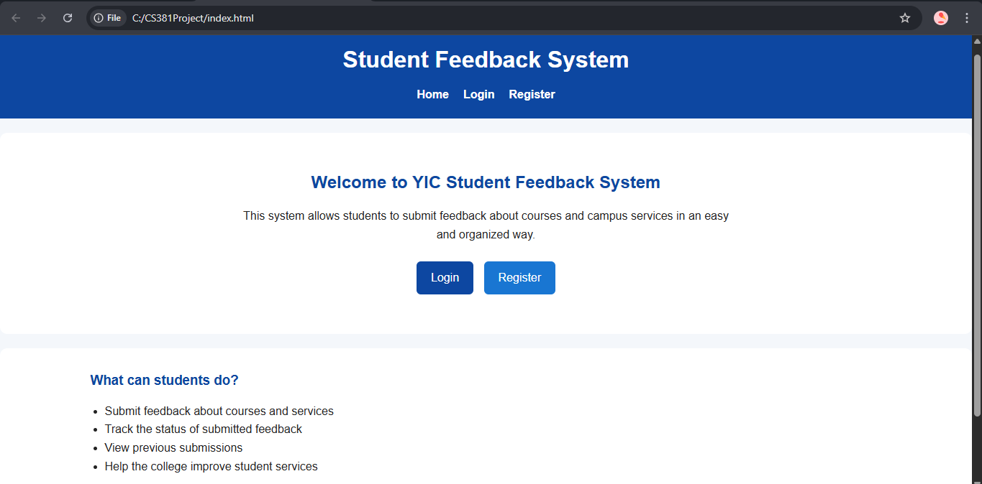
Login Page (Desktop)
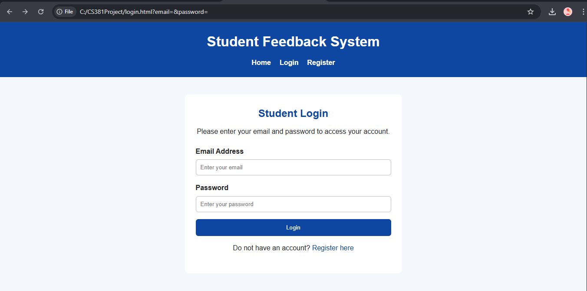

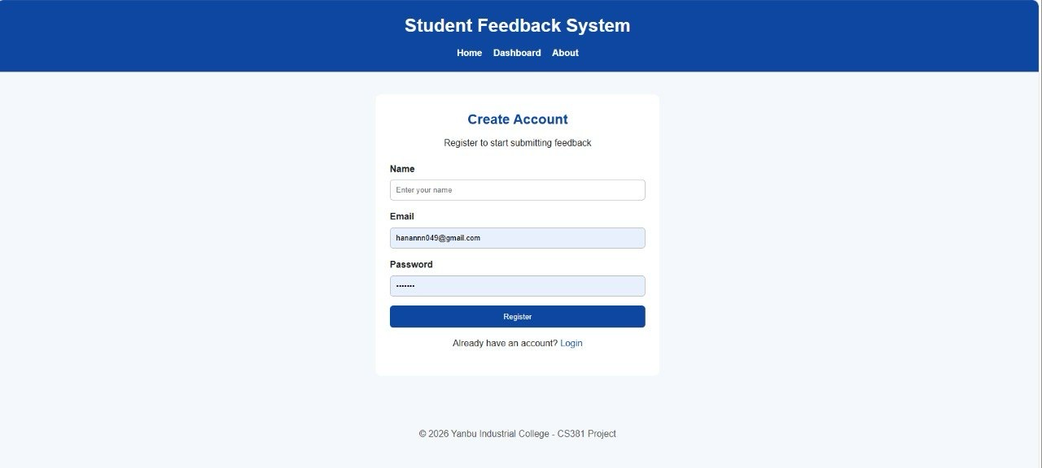
Register Page (Desktop)


Dashboard (Desktop)

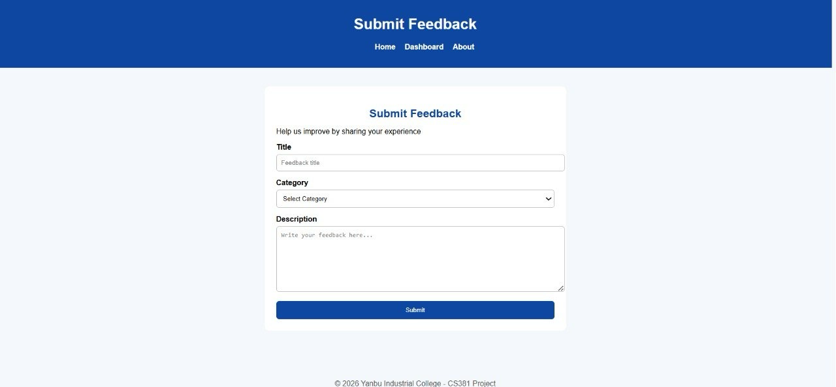
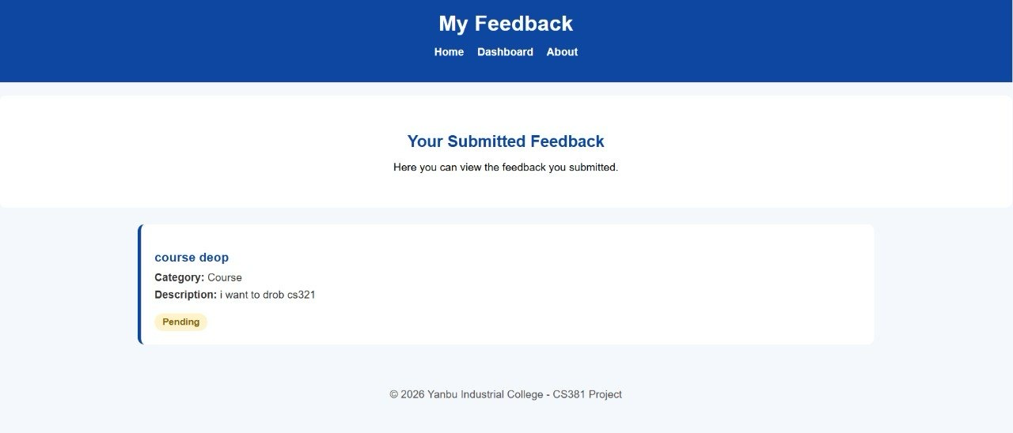
Submit Feedback Page (Desktop)

Mobile Views
Home Page (Mobile)
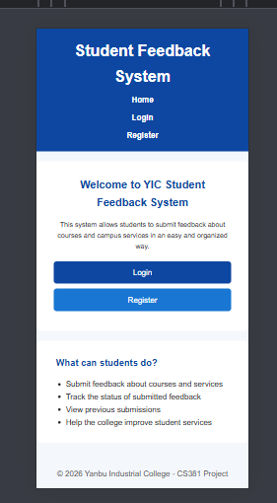
Login Page (Mobile)
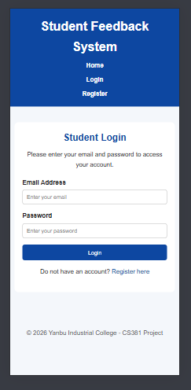

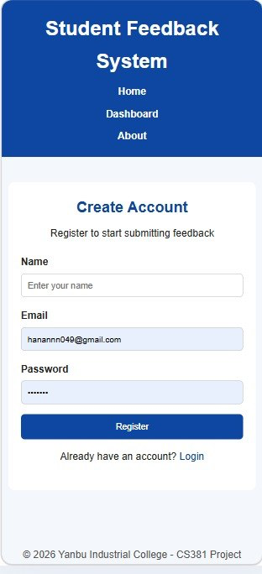
Register Page (Mobile)

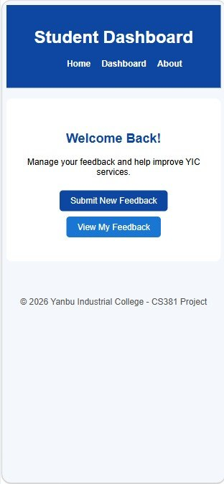
Dashboard (Mobile)
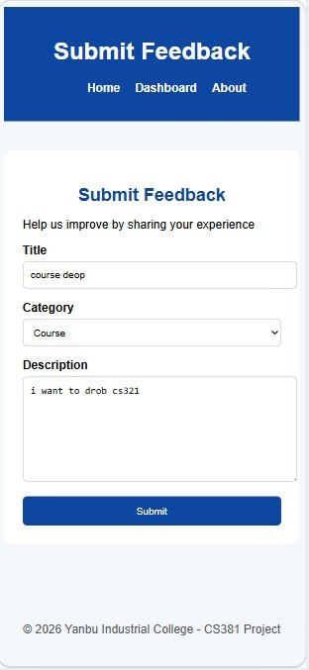
Submit Feedback Page (Mobile)
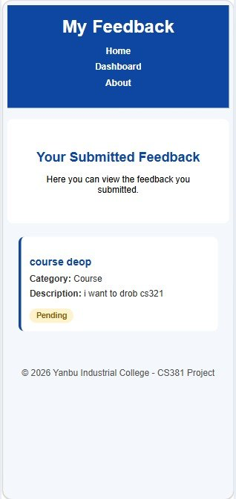

7. Work Distribution

Aseel Azoni
• Developing the Home Page
• Developing the Login Page
• Writing the CSS stylesheet
• Implementing responsive design for mobile devices

Hanan Alanazi
• Developing the Register Page
• Developing the Dashboard Page
• Developing the Submit Feedback Page
• Writing JavaScript validation functions

Shared Work
• Testing all frontend pages
• Taking desktop and mobile screenshots
• Reviewing and improving the final frontend output

